No Intersection

Definition
# Source: AI Source: Provided by: [Data Path: Persons Table -> ID Column: 1, Name_En Column: Motasem Essam] -> From: [ChatGPT] on [7/25/2026]
No Intersection occurs when two geometric objects have no common points.
In other words, the objects are completely separate and do not touch, cross, or overlap.
If two objects $A$ and $B$ have no common point:
$$\boxed{A∩B=∅}$$
where:
$$\boxed{∅=\text{Empty Set}}$$
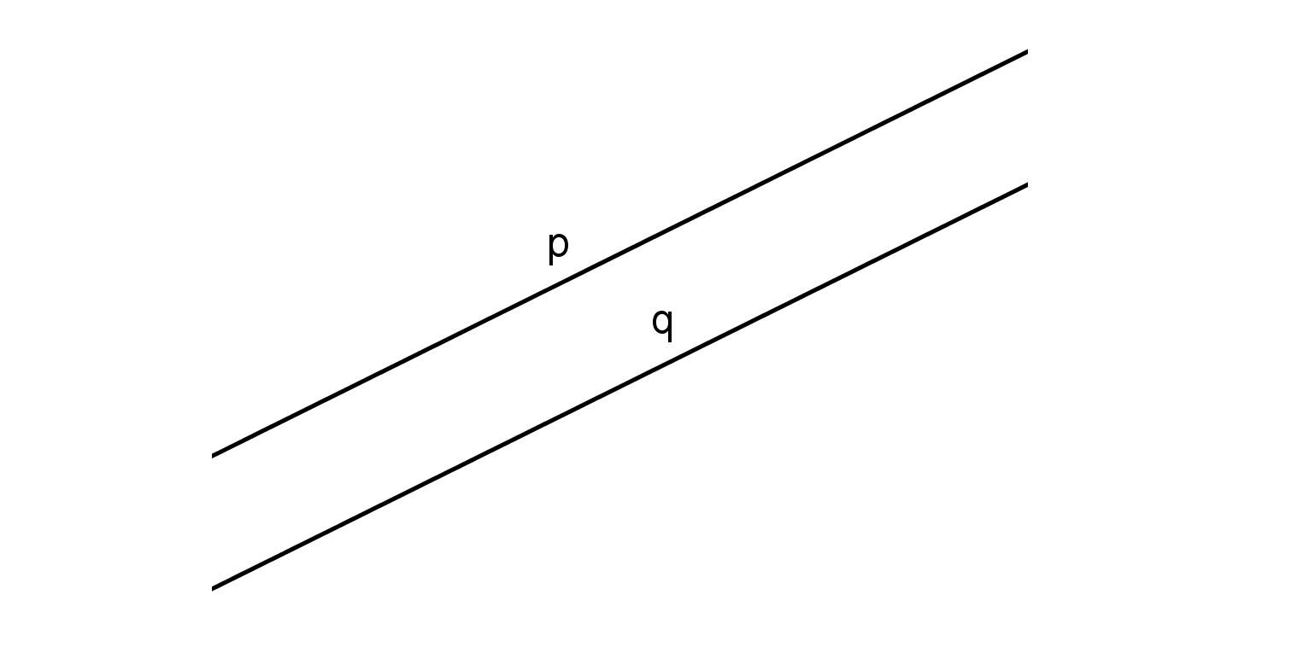
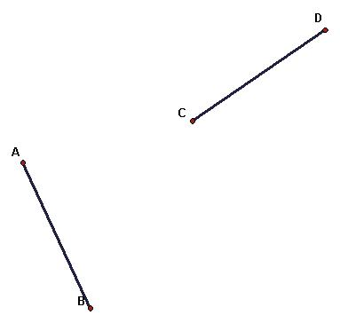
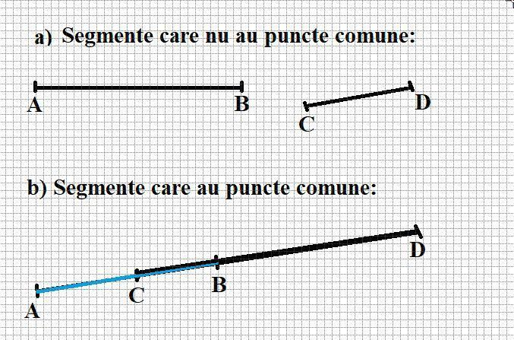

Purpose
# Source: AI Source: Provided by: [Data Path: Persons Table -> ID Column: 1, Name_En Column: Motasem Essam] -> From: [ChatGPT] on [7/25/2026]
No Intersection is used to:
- Determine whether geometric objects are completely separate.
- Identify objects that do not share any points.
- Analyze geometric relationships.
- Detect gaps between geometric objects.
- Determine whether paths or boundaries meet.
- Check for collisions in computer graphics.
- Analyze polygons and polylines.
- Support CAD, GIS, and engineering applications.

Fundamental Idea
# Source: AI Source: Provided by: [Data Path: Persons Table -> ID Column: 1, Name_En Column: Motasem Essam] -> From: [ChatGPT] on [7/25/2026]
The fundamental idea is simple:
[
$$\boxed{\text{No common point}⇒\text{No Intersection}}$$]
For example:
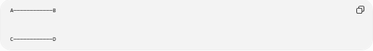
A────────────B

C────────────D
The two segments do not touch.
Therefore:
$$\boxed{\overline{AB}∩\overline{CD}=∅}$$
There is no point $P$ for which:
$$P∈\overline{AB}$$
and:
$$P∈\overline{CD}$$
at the same time.

Mathematical Representation
# Source: AI Source: Provided by: [Data Path: Persons Table -> ID Column: 1, Name_En Column: Motasem Essam] -> From: [ChatGPT] on [7/25/2026]
The intersection of two objects is represented using:
$$A∩B$$
If there is no common point:
$$\boxed{A∩B=∅}$$
The symbol ($∅$) means that the intersection contains zero points.
Therefore:
$$\boxed{\text{Number of common points}=0}$$

Simple Example
# Source: AI Source: Provided by: [Data Path: Persons Table -> ID Column: 1, Name_En Column: Motasem Essam] -> From: [ChatGPT] on [7/25/2026]
Consider two line segments:
$$\overline{AB}$$
and:
$$\overline{CD}$$
that are completely separated:
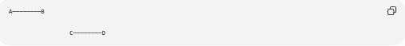
A────────B

C────────D
Then:
$$\boxed{\overline{AB}∩\overline{CD}=∅}$$
The segments have no common point.
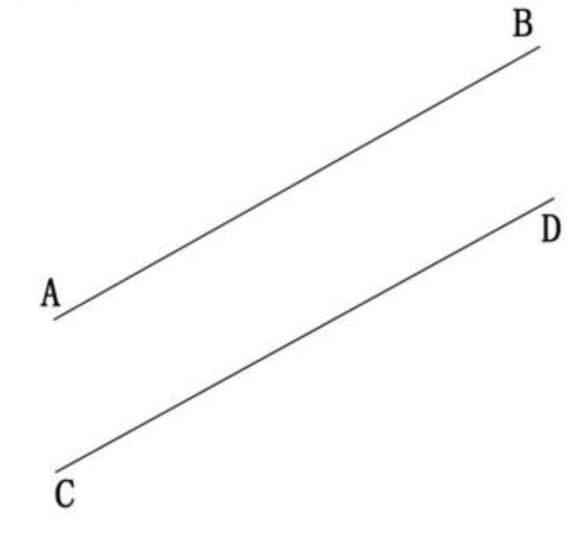
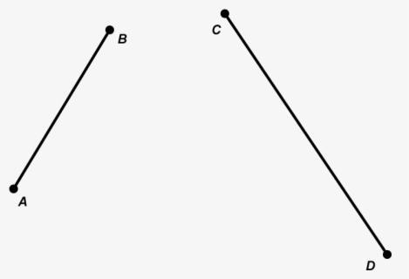

No Intersection Between Parallel Lines
# Source: AI Source: Provided by: [Data Path: Persons Table -> ID Column: 1, Name_En Column: Motasem Essam] -> From: [ChatGPT] on [7/25/2026]
Two distinct parallel lines never meet.
For example:
$$l_{1}∥l_{2}$$
and:
$$l_{1}≠l_{2}$$
Therefore:
$$\boxed{l_{1}∩l_{2}=∅}$$
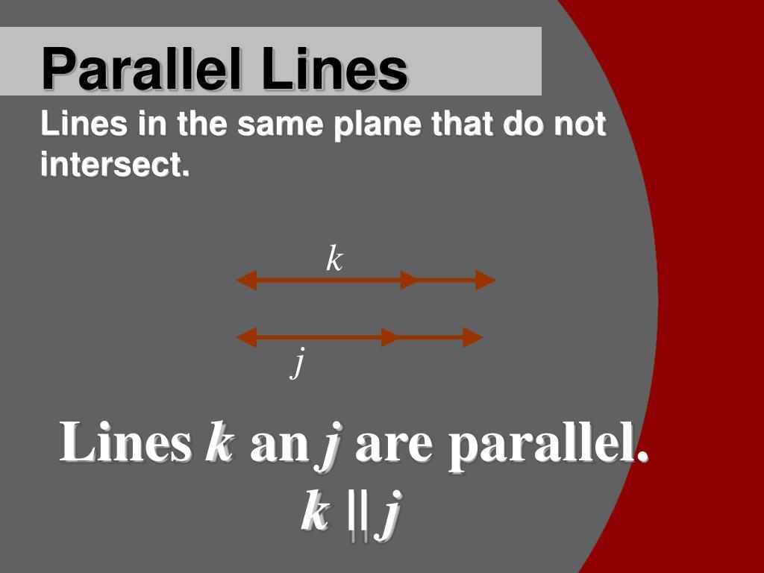
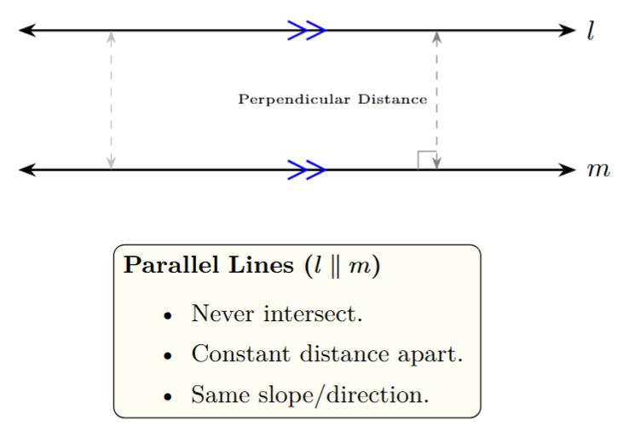
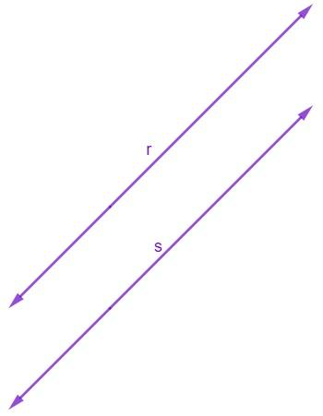
Important
This applies to distinct parallel lines.
If two lines are on exactly the same location, they are coincident, not non-intersecting.

No Intersection Between Segments
# Source: AI Source: Provided by: [Data Path: Persons Table -> ID Column: 1, Name_En Column: Motasem Essam] -> From: [ChatGPT] on [7/25/2026]
Two line segments can be parallel and separated:
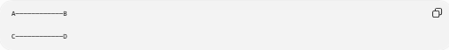
A────────────B

C────────────D
Then:
$$\boxed{\overline{AB}∩\overline{CD}=∅}$$
They have no common point.

Collinear Segments With No Intersection
# Source: AI Source: Provided by: [Data Path: Persons Table -> ID Column: 1, Name_En Column: Motasem Essam] -> From: [ChatGPT] on [7/25/2026]
Two segments can even lie on the same straight line and still have no intersection.
For example:
A──────B C──────D
The segments are collinear, but there is a gap between them.
Therefore:
$$\boxed{\overline{AB}∩\overline{CD}=∅}$$
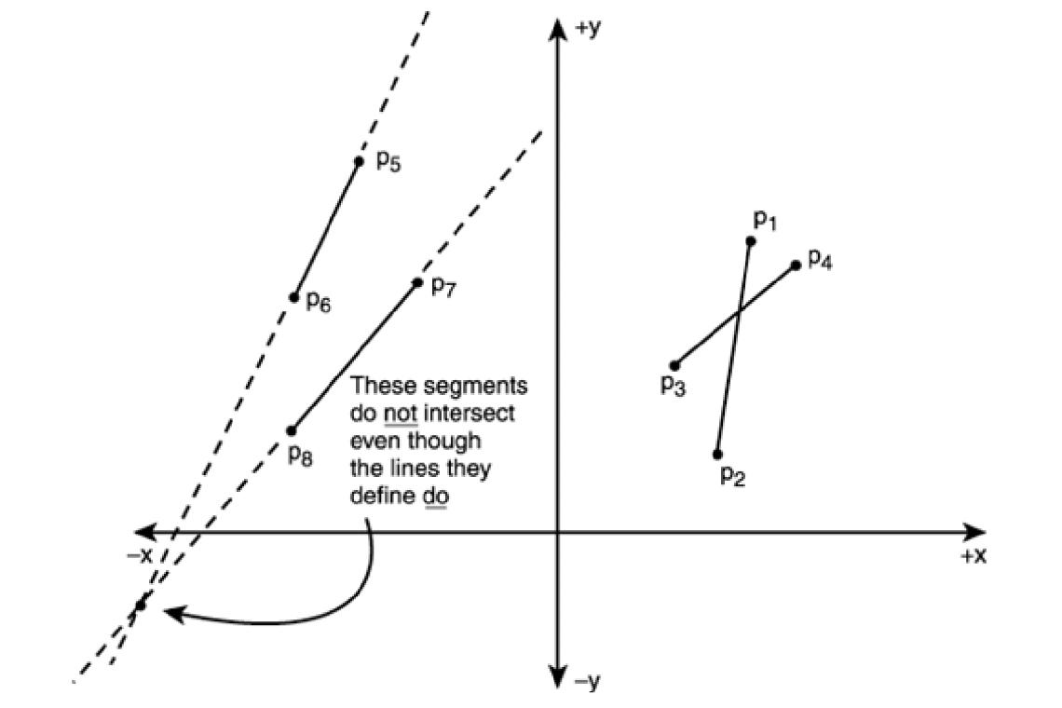
This is an important distinction:
$$\boxed{\text{Collinear}/⇒\text{Intersecting}}$$

Non-Parallel Segments With No Intersection
# Source: AI Source: Provided by: [Data Path: Persons Table -> ID Column: 1, Name_En Column: Motasem Essam] -> From: [ChatGPT] on [7/25/2026]
Two segments can have different directions but still fail to meet.
For example:
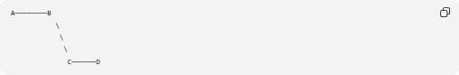
A────────B
\
\
\
C──────D
Their supporting lines might intersect somewhere outside the segments, but the actual finite segments do not intersect.
Therefore:
$$\boxed{\overline{AB}∩\overline{CD}=∅}$$
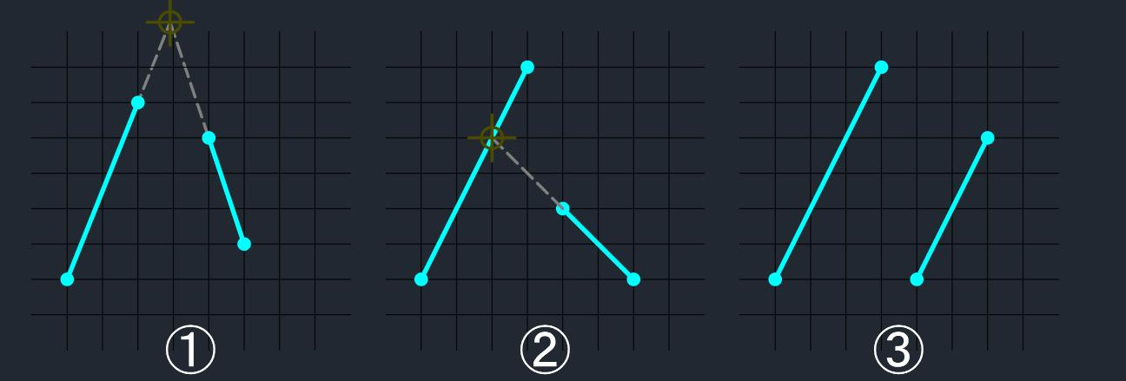

Supporting Lines vs. Finite Segments
# Source: AI Source: Provided by: [Data Path: Persons Table -> ID Column: 1, Name_En Column: Motasem Essam] -> From: [ChatGPT] on [7/25/2026]
This distinction is very important.
Imagine two segments whose infinite extensions would intersect:
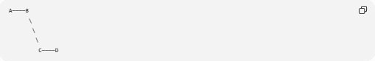
A────B
\
\
\
C────D
The infinite lines may intersect outside the segments.
However, the segments themselves have no common point.
Thus:
$$\boxed{\text{Lines may intersect while segments do not}}$$
This is why intersection tests must consider the actual endpoints of finite segments.

No Intersection vs. Endpoint Intersection
# Source: AI Source: Provided by: [Data Path: Persons Table -> ID Column: 1, Name_En Column: Motasem Essam] -> From: [ChatGPT] on [7/25/2026]
Endpoint Intersection
Two segments share exactly one endpoint:
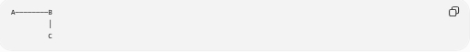
A────────B
│
C
Therefore:
$$\boxed{\overline{AB}∩\overline{BC}=B}$$
No Intersection
Two segments do not share any point:
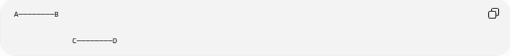
A────────B

C────────D
Therefore:
$$\boxed{\overline{AB}∩\overline{CD}=∅}$$
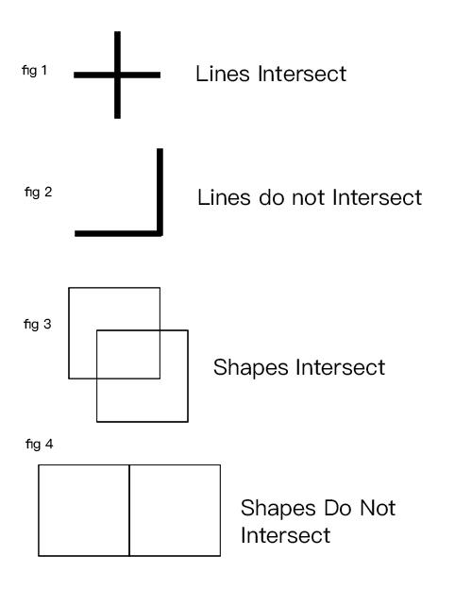
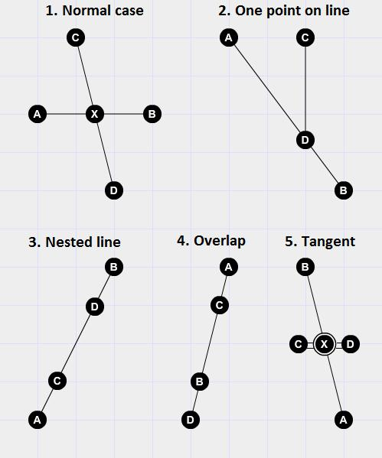

No Intersection vs. Interior Intersection
# Source: AI Source: Provided by: [Data Path: Persons Table -> ID Column: 1, Name_En Column: Motasem Essam] -> From: [ChatGPT] on [7/25/2026]
Interior Intersection
Two segments cross at an interior point:
$$\boxed{\overline{AB}∩\overline{CD}=P}$$
No Intersection
The segments do not meet:
$$\boxed{\overline{AB}∩\overline{CD}=∅}$$
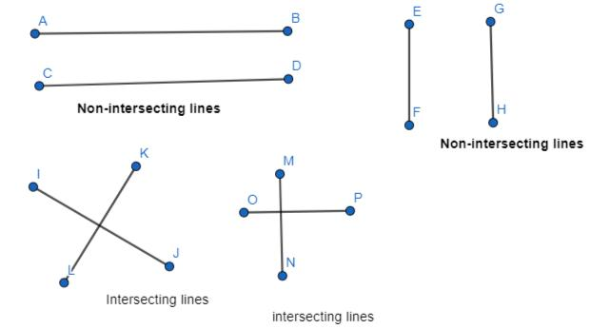
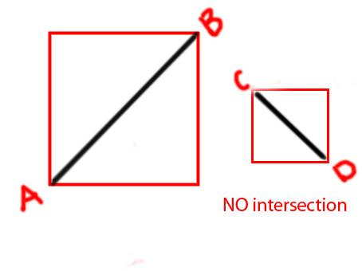

No Intersection vs. Overlapping Intersection
# Source: AI Source: Provided by: [Data Path: Persons Table -> ID Column: 1, Name_En Column: Motasem Essam] -> From: [ChatGPT] on [7/25/2026]
Overlapping Intersection
Two collinear segments share part of their length:
A────────────B
C────────────D
Their intersection is:
$$\boxed{\overline{CB}}$$
No Intersection
Two segments have no common portion:
A────────B C────────D
Therefore:
$$\boxed{\overline{AB}∩\overline{CD}=∅}$$
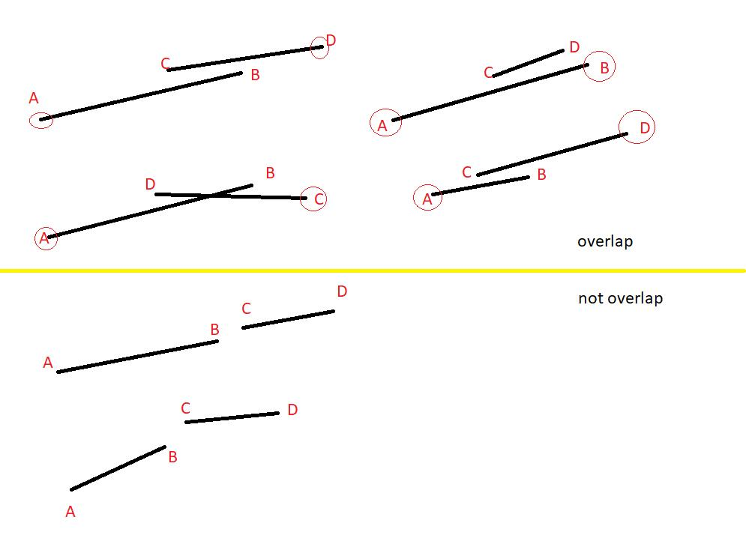

No Intersection vs. Coincident Intersection
# Source: AI Source: Provided by: [Data Path: Persons Table -> ID Column: 1, Name_En Column: Motasem Essam] -> From: [ChatGPT] on [7/25/2026]
These are essentially opposite situations.
No Intersection
$$\boxed{A∩B=∅}$$
There are zero common points.
Coincident Intersection
$$\boxed{A∩B=A=B}$$
Every point is common.
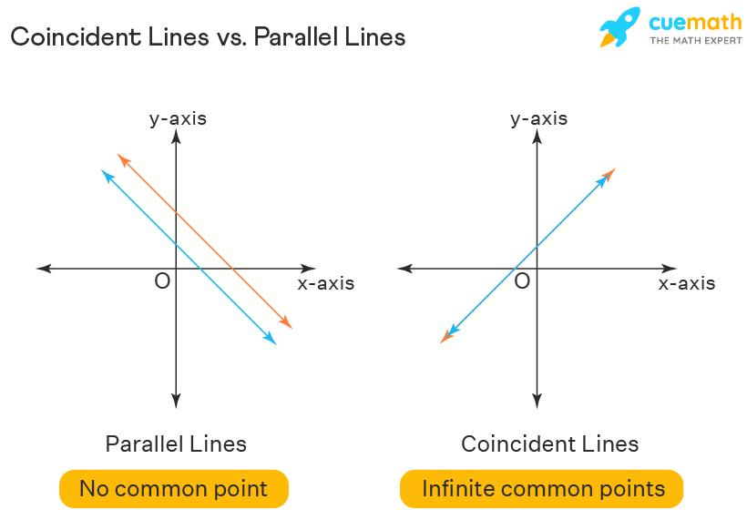
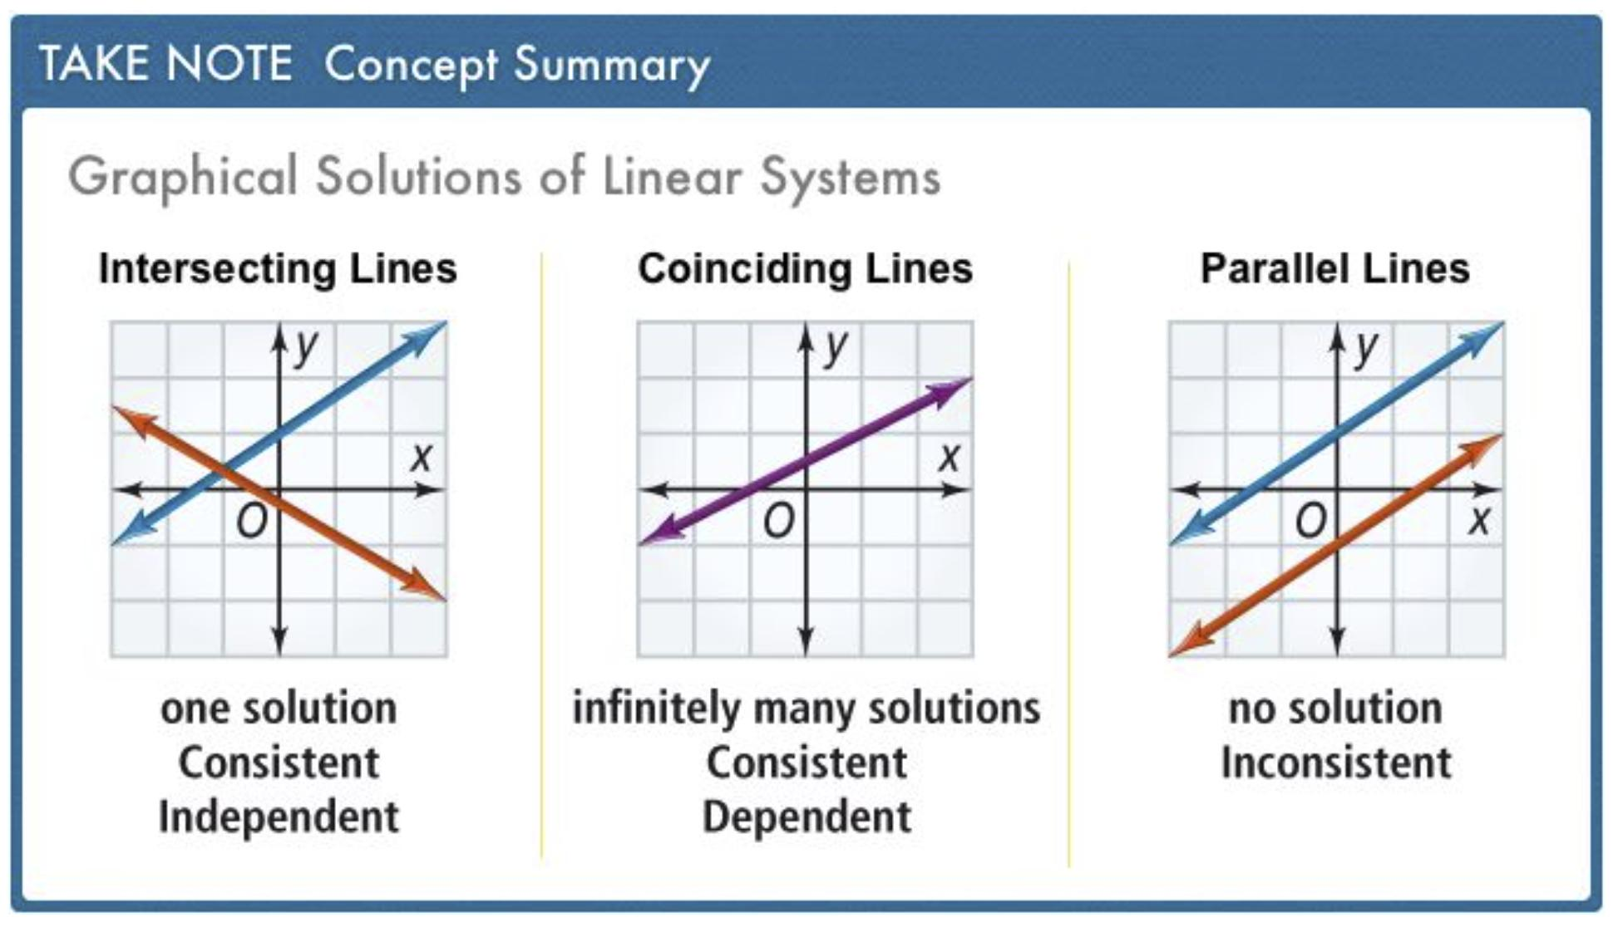
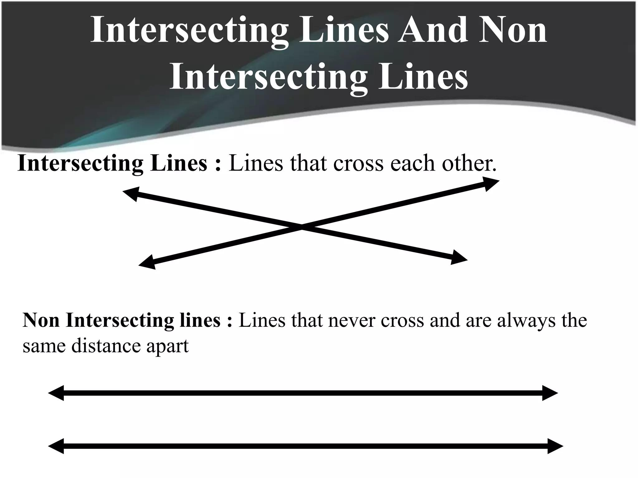

Number of Common Points
# Source: AI Source: Provided by: [Data Path: Persons Table -> ID Column: 1, Name_En Column: Motasem Essam] -> From: [ChatGPT] on [7/25/2026]
A useful way to classify intersections is by the number and type of common points.
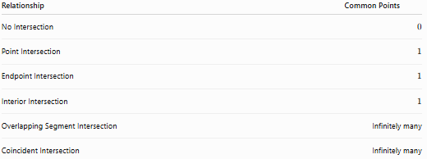
Relationship | Common Points
No Intersection | $$0$$
Point Intersection | $$1$$
Endpoint Intersection | $$1$$
Interior Intersection | $$1$$
Overlapping Segment Intersection | Infinitely many
Coincident Intersection | Infinitely many
For No Intersection:
$$\boxed{N=0}$$

Coordinate Geometry
# Source: AI Source: Provided by: [Data Path: Persons Table -> ID Column: 1, Name_En Column: Motasem Essam] -> From: [ChatGPT] on [7/25/2026]
Suppose:
$$A=\left(1,1\right) \\ B=\left(5,1\right)$$
and:
$$C=\left(1,4\right) \\ D=\left(5,4\right)$$
The first segment lies on:
$$y=1$$
and the second lies on:
$$y=4$$
Since:
$$1≠4$$
the horizontal segments are separated.
Therefore:
$$\boxed{\overline{AB}∩\overline{CD}=∅}$$
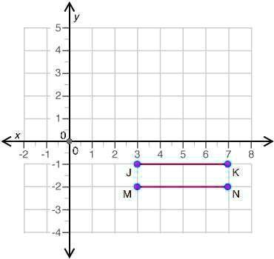
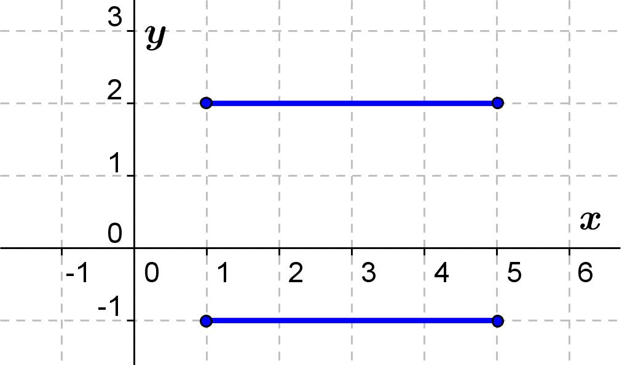
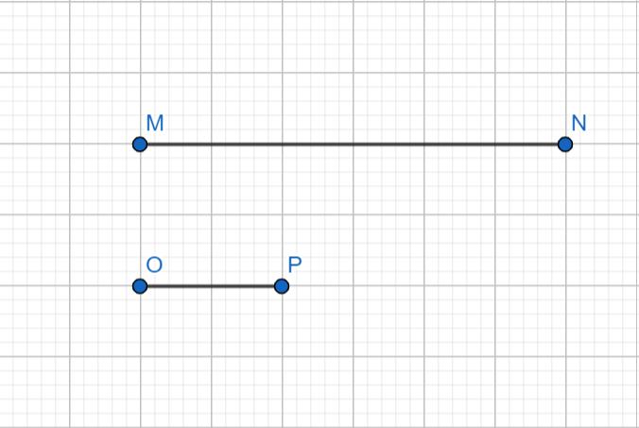

No Intersection on a Number Line
# Source: AI Source: Provided by: [Data Path: Persons Table -> ID Column: 1, Name_En Column: Motasem Essam] -> From: [ChatGPT] on [7/25/2026]
Consider:
$$\left[1,4\right]$$
and:
$$\left[7,10\right]$$
There is no number that belongs to both intervals.
Therefore:
$$\boxed{\left[1,4\right]∩\left[7,10\right]=∅}$$
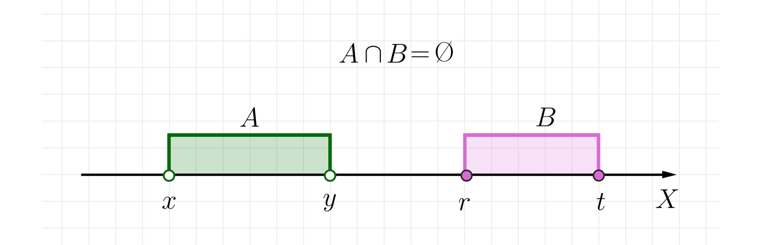
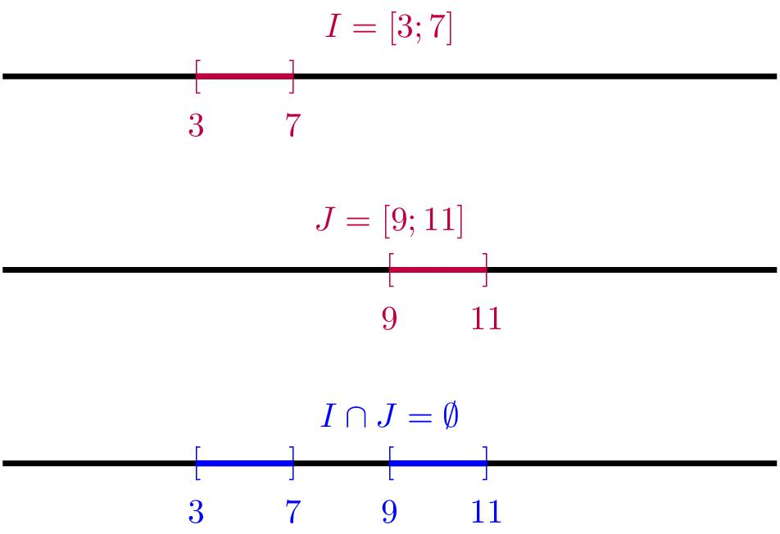
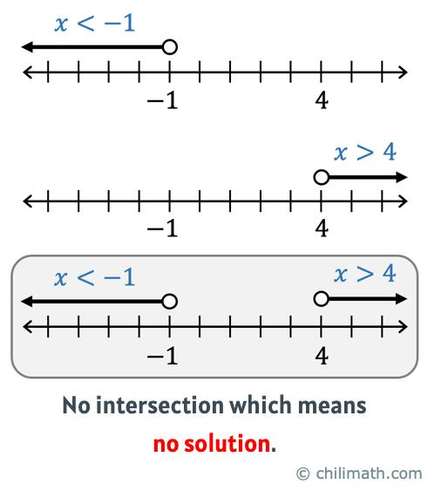

Mathematical Condition for Disjoint Intervals
# Source: AI Source: Provided by: [Data Path: Persons Table -> ID Column: 1, Name_En Column: Motasem Essam] -> From: [ChatGPT] on [7/25/2026]
For two intervals:
$$\left[a,b\right]$$
and:
$$\left[c,d\right]$$
there is no intersection if:
$$\boxed{b<c}$$
or:
$$\boxed{d<a}$$
For example:
$$\left[2,5\right]$$
and:
$$\left[8,12\right]$$
satisfy:
$$5<8$$
Therefore:
$$\boxed{\left[2,5\right]∩\left[8,12\right]=∅}$$

Distance Between Non-Intersecting Objects
# Source: AI Source: Provided by: [Data Path: Persons Table -> ID Column: 1, Name_En Column: Motasem Essam] -> From: [ChatGPT] on [7/25/2026]
No Intersection tells us that the objects have no common point, but it does not tell us how far apart they are.
For example:
A────B C────D
The segments may be:
- $1$ unit apart.
- $10$ units apart.
- $100$ units apart.
All three cases still satisfy:
$$\boxed{\overline{AB}∩\overline{CD}=∅}$$

No Intersection in Polygons
# Source: AI Source: Provided by: [Data Path: Persons Table -> ID Column: 1, Name_En Column: Motasem Essam] -> From: [ChatGPT] on [7/25/2026]
Two polygon edges may have no intersection.
For example, two non-adjacent edges of a polygon may be completely separate:
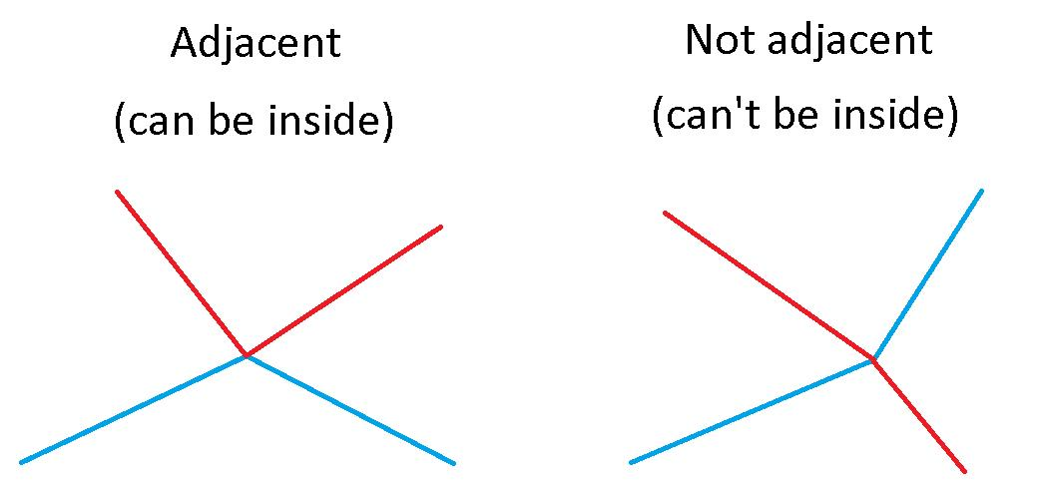
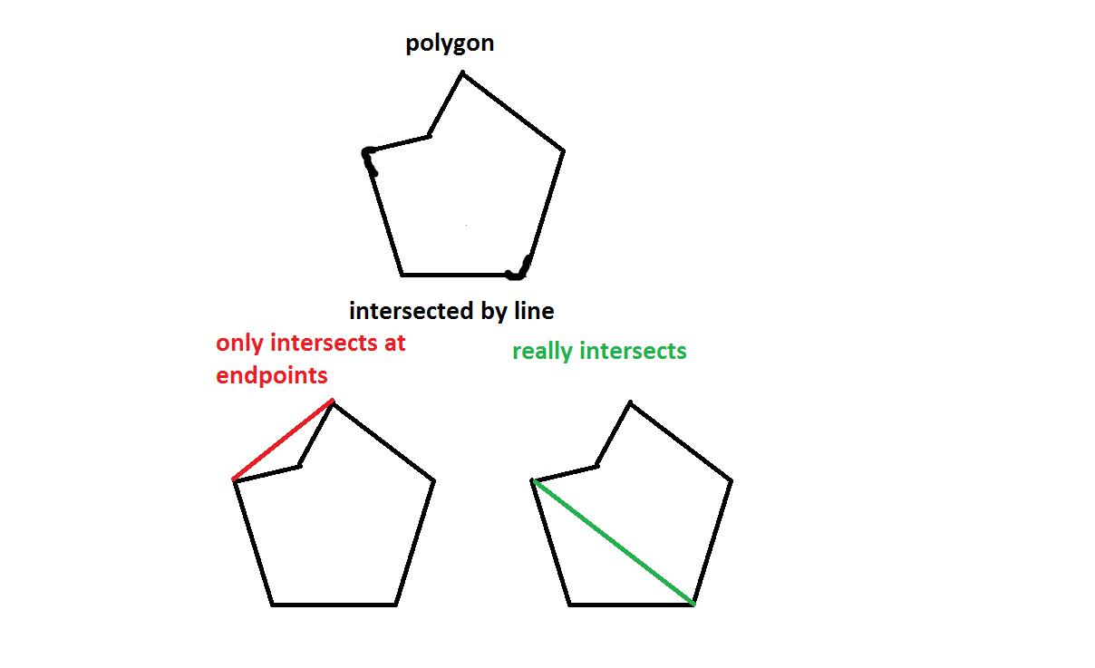
Mathematically:
$$\boxed{E_{1}∩E_{2}=∅}$$
This is particularly common when analyzing convex polygons.

No Intersection in Polylines
# Source: AI Source: Provided by: [Data Path: Persons Table -> ID Column: 1, Name_En Column: Motasem Essam] -> From: [ChatGPT] on [7/25/2026]
Two polylines can be completely separate.
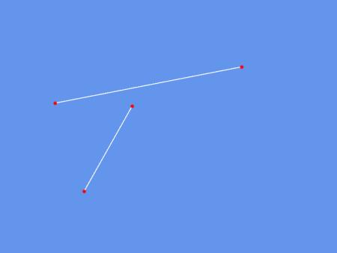
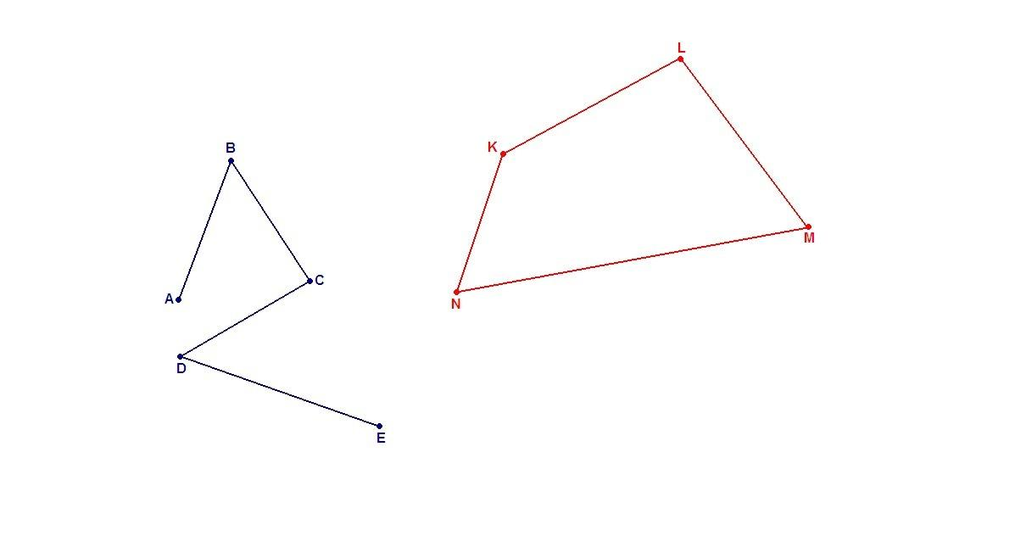
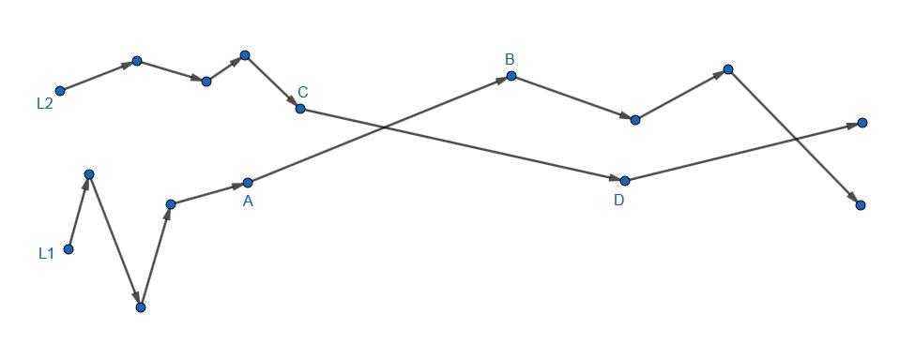
For example:
- Two roads that never meet.
- Two hiking routes that remain separate.
- Two railway paths that do not cross.
- Two CAD paths separated from one another.

No Intersection in CAD
# Source: AI Source: Provided by: [Data Path: Persons Table -> ID Column: 1, Name_En Column: Motasem Essam] -> From: [ChatGPT] on [7/25/2026]
CAD systems need to determine whether geometric elements intersect.
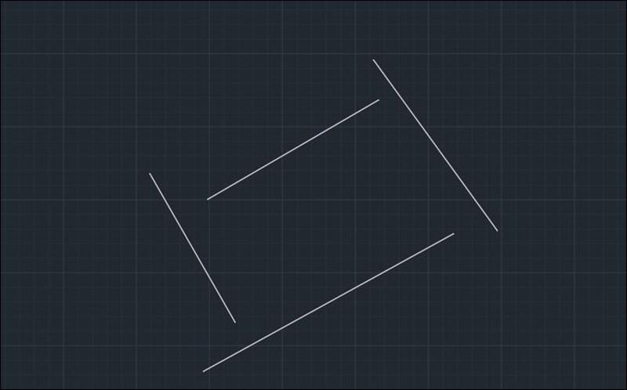
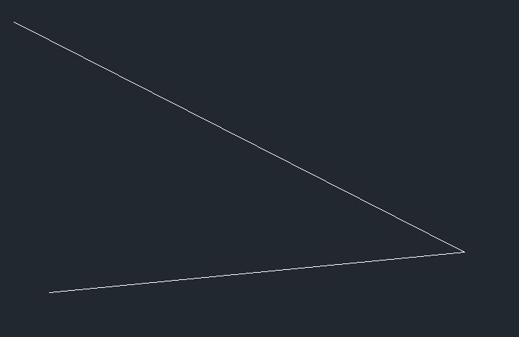
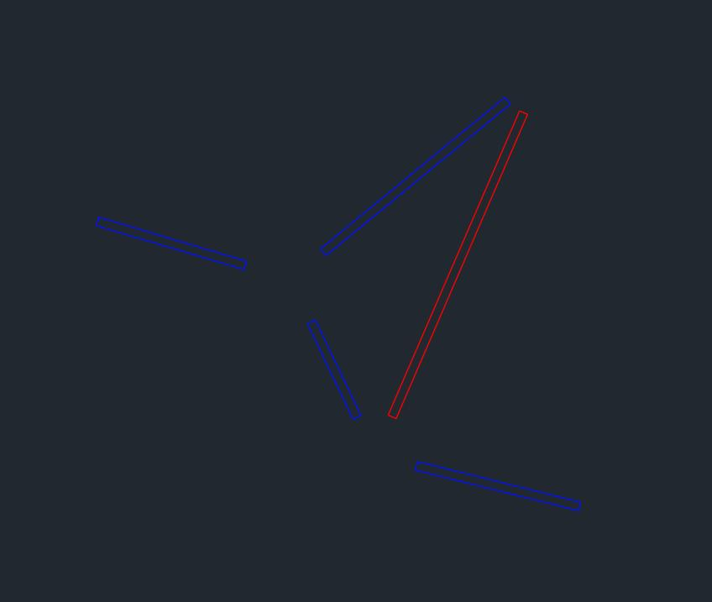
No-intersection detection can be used to:
- Check clearances.
- Detect gaps.
- Verify component separation.
- Prevent unwanted connections.
- Analyze technical drawings.
- Perform collision checks.

No Intersection in GIS
# Source: AI Source: Provided by: [Data Path: Persons Table -> ID Column: 1, Name_En Column: Motasem Essam] -> From: [ChatGPT] on [7/25/2026]
GIS applications frequently determine whether geographic features meet.
Examples include:
- Roads.
- Railway lines.
- Pipelines.
- Administrative boundaries.
- Trails.
- Utility networks.
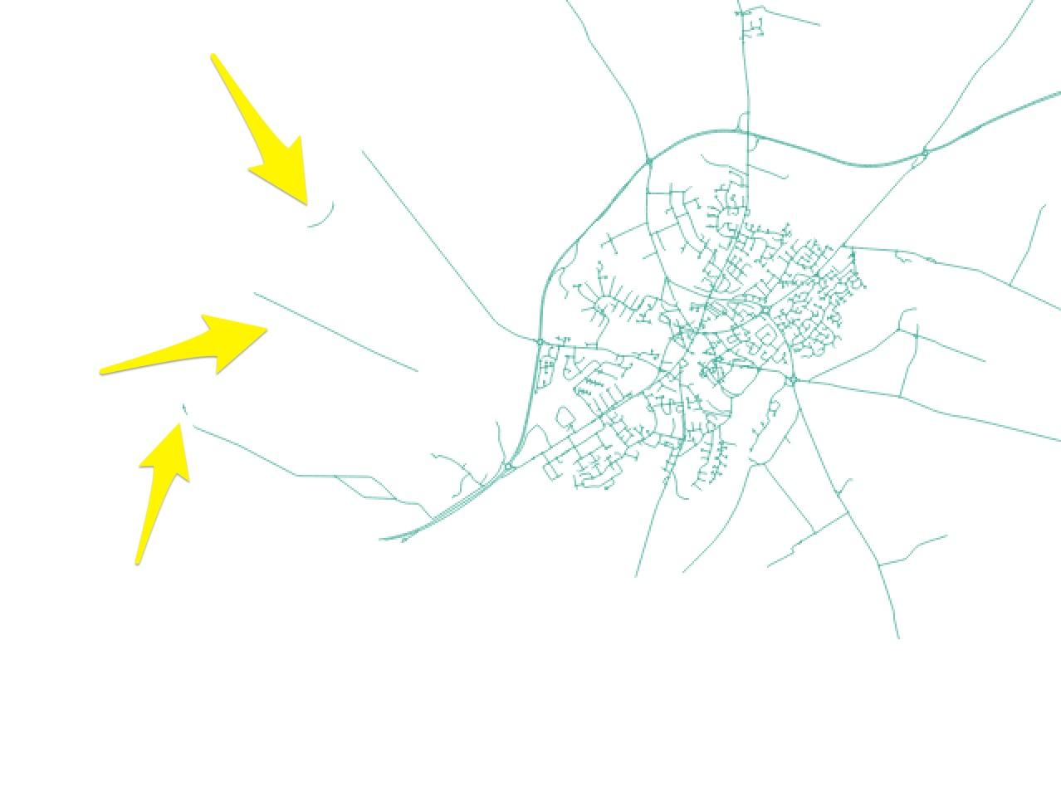
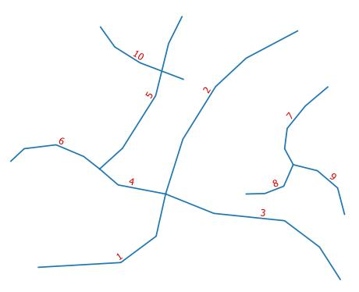
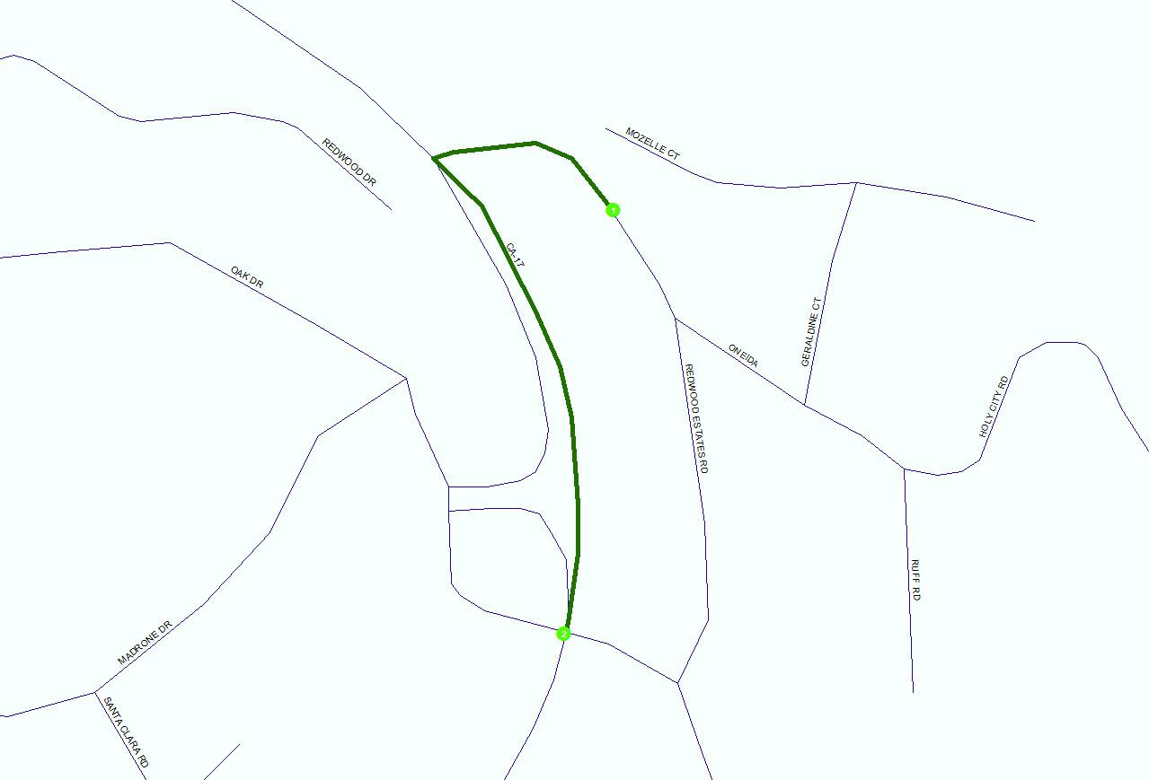
If two line features do not share any point:
$$\boxed{L_{1}∩L_{2}=∅}$$

No Intersection in Computer Graphics
# Source: AI Source: Provided by: [Data Path: Persons Table -> ID Column: 1, Name_En Column: Motasem Essam] -> From: [ChatGPT] on [7/25/2026]
In computer graphics, determining that objects do not intersect is useful for:
- Collision detection.
- Path planning.
- Polygon clipping.
- Visibility calculations.
- Vector graphics.
- Shape analysis.
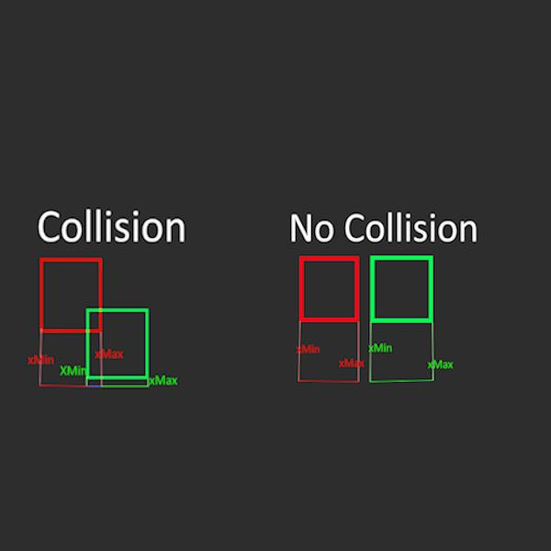
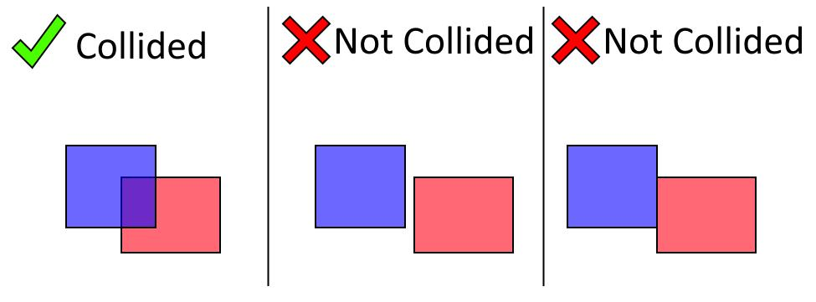
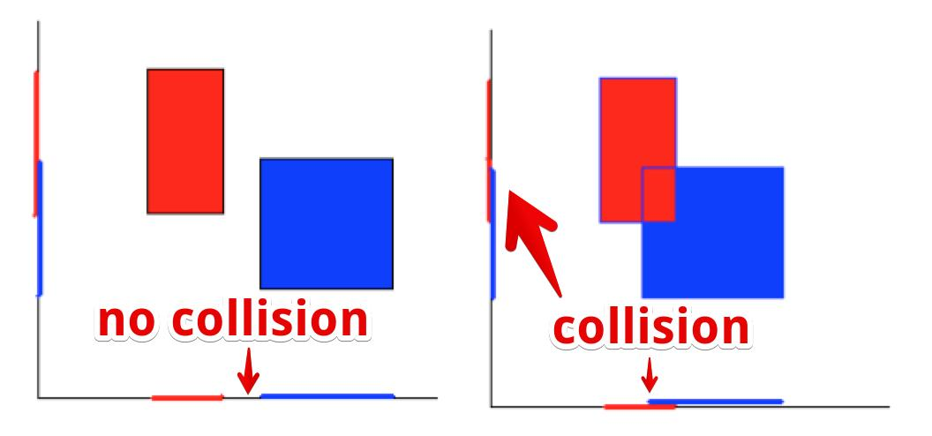
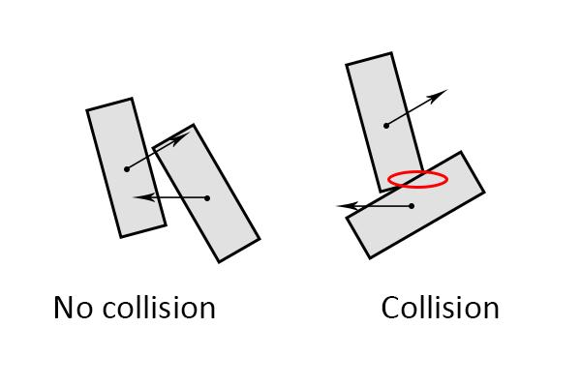
For example, if two object boundaries do not intersect, this can be evidence that the objects are not colliding, although complete collision analysis may also require checking containment.

Real-World Examples
# Source: AI Source: Provided by: [Data Path: Persons Table -> ID Column: 1, Name_En Column: Motasem Essam] -> From: [ChatGPT] on [7/25/2026]
No Intersection can represent:
- Two roads that do not meet.
- Two railway sections separated by distance.
- Two walls with a gap between them.
- Two routes that never cross.
- Two property boundaries that do not touch.
- Two structural components that are separated.
- Two independent paths on a map.
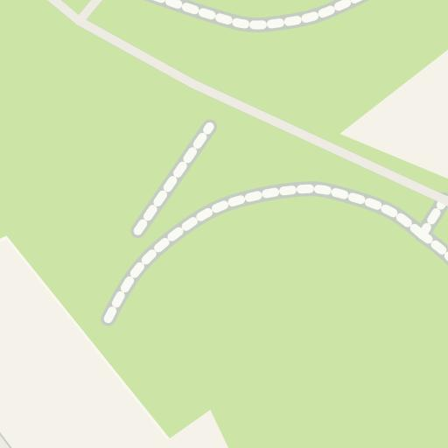
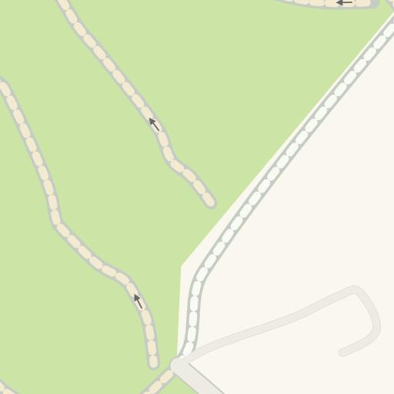
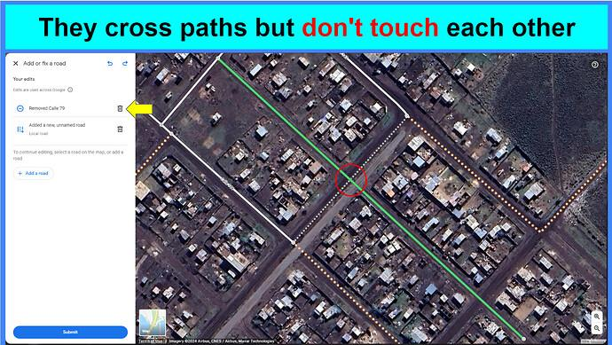

Applications
# Source: AI Source: Provided by: [Data Path: Persons Table -> ID Column: 1, Name_En Column: Motasem Essam] -> From: [ChatGPT] on [7/25/2026]
No Intersection is important in:
- Plane Geometry
- Coordinate Geometry
- Computational Geometry
- Polygon Theory
- Polyline Geometry
- CAD
- GIS
- Architecture
- Civil Engineering
- Mechanical Engineering
- Surveying
- Cartography
- Computer Graphics
- Robotics
- Navigation
- Collision Detection

Advantages
# Source: AI Source: Provided by: [Data Path: Persons Table -> ID Column: 1, Name_En Column: Motasem Essam] -> From: [ChatGPT] on [7/25/2026]
Studying No Intersection helps to:
- Identify separated geometric objects.
- Detect gaps between segments.
- Determine whether paths meet.
- Check geometric clearances.
- Prevent unwanted collisions.
- Verify CAD designs.
- Analyze geographic networks.
- Simplify computational geometry problems.

Limitations
# Source: AI Source: Provided by: [Data Path: Persons Table -> ID Column: 1, Name_En Column: Motasem Essam] -> From: [ChatGPT] on [7/25/2026]
No Intersection:
- Only tells us that the objects have no common points.
- Does not by itself provide the distance between objects.
- Can require detailed endpoint and orientation analysis.
- Must be distinguished from an intersection occurring outside a finite segment.
- Can be difficult to determine computationally when coordinates are subject to numerical precision errors.

Comparison with Related Concepts
# Source: AI Source: Provided by: [Data Path: Persons Table -> ID Column: 1, Name_En Column: Motasem Essam] -> From: [ChatGPT] on [7/25/2026]
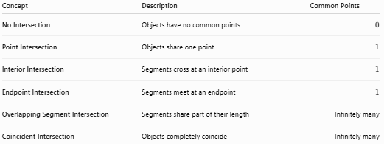
Concept | Description | Common Points
No Intersection | Objects have no common points | $$0$$
Point Intersection | Objects share one point | $$1$$
Interior Intersection | Segments cross at an interior point | $$1$$
Endpoint Intersection | Segments meet at an endpoint | $$1$$
Overlapping Segment Intersection | Segments share part of their length | Infinitely many
Coincident Intersection | Objects completely coincide | Infinitely many

Complete Intersection Classification
# Source: AI Source: Provided by: [Data Path: Persons Table -> ID Column: 1, Name_En Column: Motasem Essam] -> From: [ChatGPT] on [7/25/2026]
The major intersection relationships can be summarized as:
$$\boxed{\begin{aligned}\text{No Intersection}→∅ \\ \text{Point Intersection}→P \\ \text{Endpoint Intersection}→P \\ \text{Interior Intersection}→P \\ \text{Overlapping Segment Intersection}→\overline{PQ} \\ \text{Coincident Intersection}→\text{Entire Object}\end{aligned}}$$
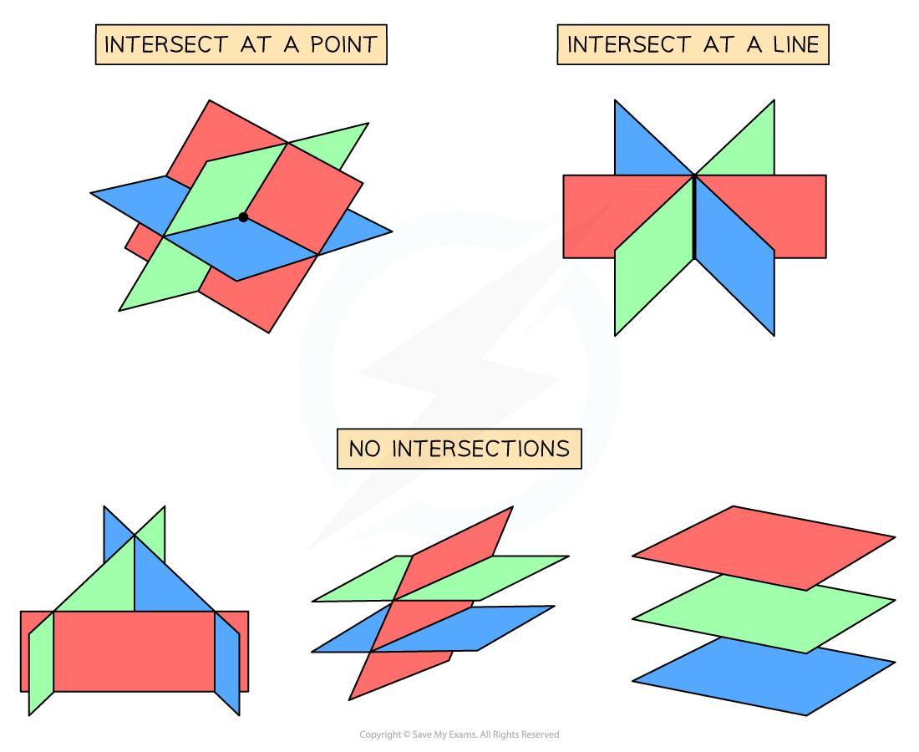
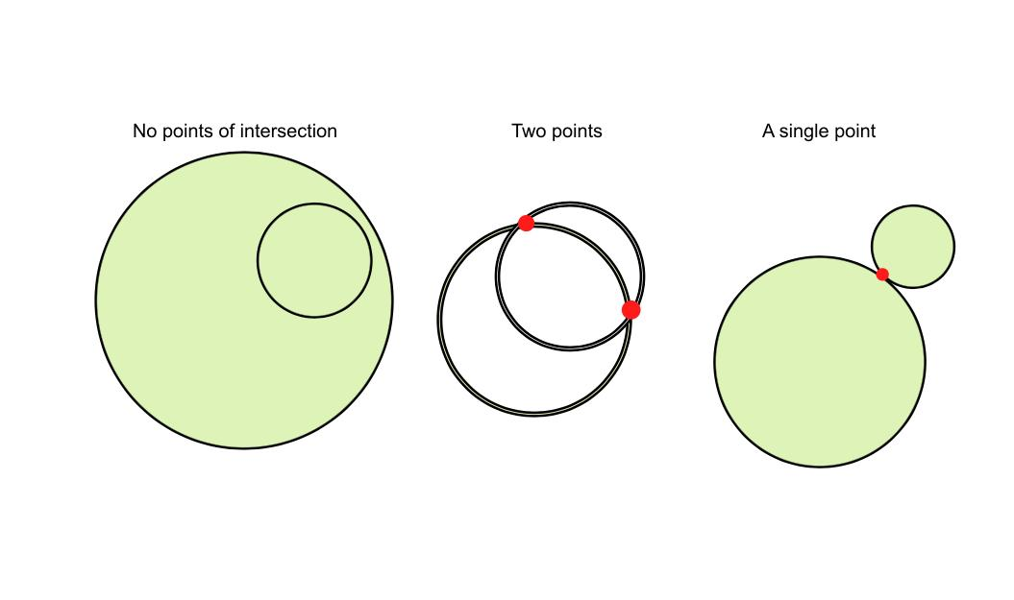
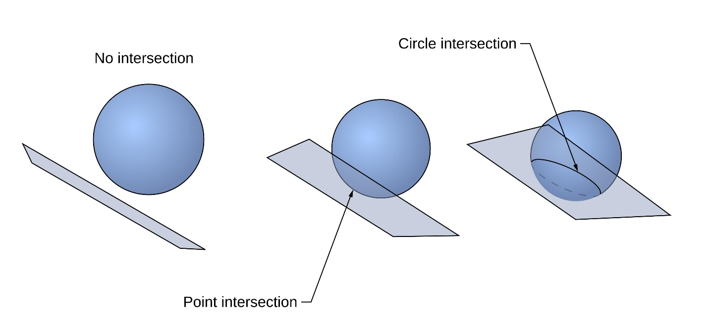
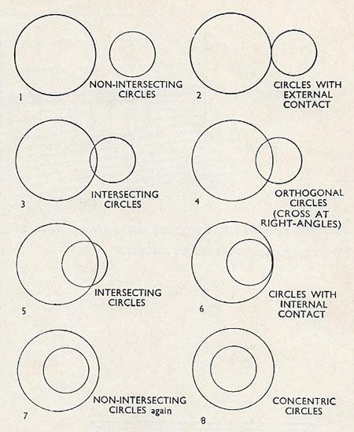

Key Points
# Source: AI Source: Provided by: [Data Path: Persons Table -> ID Column: 1, Name_En Column: Motasem Essam] -> From: [ChatGPT] on [7/25/2026]
- No Intersection means two geometric objects have no common points.
- Its mathematical representation is:
$$\boxed{A∩B=∅}$$
- The number of common points is:
$$\boxed{0}$$
- Two objects may be:
  - Parallel and separate.
  - Collinear but separated.
  - Non-parallel and still non-intersecting.
- The infinite supporting lines may intersect even when the finite segments do not.
- No Intersection is different from:
  - Point Intersection.
  - Endpoint Intersection.
  - Interior Intersection.
  - Overlapping Segment Intersection.
  - Coincident Intersection.

Conclusion
# Source: AI Source: Provided by: [Data Path: Persons Table -> ID Column: 1, Name_En Column: Motasem Essam] -> From: [ChatGPT] on [7/25/2026]
No Intersection occurs when two geometric objects have no point in common. The intersection is represented by the empty set:
$$\boxed{A∩B=∅}$$
This relationship can occur between parallel objects, separated collinear segments, or non-parallel segments whose finite portions do not meet. It is important to distinguish the actual finite objects from their infinite supporting lines. No Intersection is a fundamental concept in plane geometry and is widely used in coordinate geometry, computational geometry, CAD, GIS, engineering, surveying, computer graphics, robotics, and collision detection.

